Net 1060 Introduction to Networks Lab: # 11.9.3

Name:

Follow the instructions down below for the lab itself. For this lab, all answers need to be in blue font. For the questions right below, answer in complete sentences. Ensure you paste the screen shot of your score page at the bottom of the document. Even if this does not let you see your grade, still take a screen shot of the score page showing congratulations “your name” you have completed the exercise is pasted at the bottom of this document. You will then need to upload both this word document and your packet tracer file to the assignments link within Netacad. Let the instructor know if you have any questions.

Lab Analysis Report

1. Using complete sentences summarize work you completed during the lab.
First, I divided the subnet masks for all the different rooms. Then, I assigned ip address to the branch routers. Then, I assigned Ip addresses to the end devices. Then, I configured the routers, switches, and end devices with their ip addresses, subnet masks, and default gateways. Finally, I pinged the ip addresses to verify connectivity.

2. Using complete sentences describe what you learned from the lab. Hint; look at the lab objectives listed at the top of the lab section.
In this lab I learned how to apply the subnetting skills that we just learned. I learned how to assign ip addresses and configure them so that they are not overlapping with each other. I learned more about the overall picture of using subnets and different ip addresses and default gateways.

Problems Encountered

1. Using complete sentences describe any problem(s) experienced during lab.
I didn’t experience any problems.

2. Using complete sentences describe how you solved your problem(s).

3. Using complete sentences explain if you needed any assistance with the lab; then list what you learned from that assistance.

Packet Tracer - VLSM Design and Implementation Practice Topology
You will receive one of three possible topologies.

Addressing Table
Device | Interface | IP Address | Subnet Mask | Default Gateway
Branch 1]] | G0/0 | 192.168.72.129 | 255.255.255.240 | N/A
blank | G0/1 | 192.168.72.97blank | 255.255.255.240blank | N/A
 | S0/0/0 | 192.168.72.145blank | 255.255.255.240blank | N/A
Branch 2 | G0/0 | 192.168.72.1blank | 255.255.255.240blank | N/A
blank | G0/1 | 192.168.72.65blank | 255.255.255.240blank | N/A
blank | S0/0/0 | 192.168.72.146blank | 255.255.255.240blank | N/A
Room-114 | VLAN 1 | 192.168.72.128/28blank | 255.255.255.240blank | 192.168.72.129
Room-279 | VLAN 1 | 192.168.72.96/27 | 255.255.255.224 | 192.168.72.97blank
Room-312 | VLAN 1 | 192.168.72.64/27 | 255.255.255.224 | 192.168.72.65blank
Room-407 | VLAN 1 | 192.168.72.0/26lank | 255.255.255.192lank | 192.168.72.1blank
PC-A | NIC | 192.168.72.142blank | 255.255.255.240blank | 192.168.72.129blank
PC-Bblank | NIC | 192.168.72.126 | 255.255.255.224 | 192.168.72.97
PC-Cblank | NIC | 192.168.72.94 | 255.255.255.224 | 192.168.72.65
PC-Dblank | NIC | 192.168.72.62 | 255.255.255.192 | 192.168.72.1

Objectives
Part 1: Examine the Network Requirements
Part 2: Design the VLSM Addressing Scheme
Part 3: Assign IP Addresses to Devices and Verify Connectivity

Background
In this activity, you are given a /24 network address to use to design a VLSM addressing scheme. Based on a set of requirements, you will assign subnets and addressing, configure devices and verify connectivity.

Instructions

Examine the Network Requirements

Determine the number of subnets needed.
You will subnet the network address . The network has the following requirements:
- LAN will require host IP addresses
- LAN will require host IP addresses
- LAN will require host IP addresses
- LAN will require host IP addresses

Question:
How many subnets are needed in the network topology?
There are 5 subnets needed. your answers here.

Determine the subnet mask information for each subnet.

Questions:
      - Which subnet mask will accommodate the number of IP addresses required for ?
How many usable host addresses will this subnet support?
The subnet mask is 255.255.255.240 and there are 14 usable host addresses for room 114. your answers here.
      - Which subnet mask will accommodate the number of IP addresses required for ?
How many usable host addresses will this subnet support?
The subnet mask is 255.255.255.224 and there are 30 usable host addresses for room 279. your answers here.
      - Which subnet mask will accommodate the number of IP addresses required for ?
How many usable host addresses will this subnet support?
The subnet mask is 255.255.255.224 and there are 30 usable host addresses for room 312. your answers here.
      - Which subnet mask will accommodate the number of IP addresses required for ?
How many usable host addresses will this subnet support?
The subnet mask is 255.255.255.192 and there are 62 usable host address for room 407. your answers here.
      - Which subnet mask will accommodate the number of IP addresses required for the connection between and ?
The subnet mask 255.255.255.240 will be used. your answers here.

Design the VLSM Addressing Scheme

Divide the network based on the number of hosts per subnet.
      - Use the first subnet to accommodate the largest LAN.
      - Use the second subnet to accommodate the second largest LAN.
      - Use the third subnet to accommodate the third largest LAN.
      - Use the fourth subnet to accommodate the fourth largest LAN.
      - Use the fifth subnet to accommodate the connection between and .

Document the VLSM subnets.
Complete the Subnet Table, listing the subnet descriptions (e.g. [[S1Name]] LAN), number of hosts needed, then network address for the subnet, the first usable host address, and the broadcast address. Repeat until all addresses are listed.
Subnet Table
Subnet Description | Number of Hosts Needed | Network Address/CIDR | First Usable Host Address | Broadcast Address
Room-407 | 58 | 192.168.72.0/26 | 192.168.72.1 | 192.168.72.63
Room-312 | 29 | 192.168.72.64/27 | 192.168.72.65 | 192.168.72.95
Room-279 | 15 | 192.168.72.96/27 | 192.168.72.97 | 192.168.72.127
Room-114 | 7 | 192.168.72.128/28 | 192.168.72.129 | 192.168.72.143
Branch 1 and 2 | 6 | 192.168.72.144/28 | 192.168.72.145 | 192.168.72.159

Document the addressing scheme.
      - Assign the first usable IP addresses to for the two LAN links and the WAN link.
      - Assign the first usable IP addresses to for the two LAN links. Assign the last usable IP address for the WAN link.
      - Assign the second usable IP addresses to the switches.
      - Assign the last usable IP addresses to the hosts.

Assign IP Addresses to Devices and Verify Connectivity
Most of the IP addressing is already configured on this network. Implement the following steps to complete the addressing configuration.

Configure IP addressing on the router LAN interfaces.

Configure IP addressing on the , switch including the default gateway.

Configure IP addressing on , including the default gateway.

Verify connectivity.
You can only verify connectivity from , , and . However, you should be able to ping every IP address listed in the Addressing Table.
End 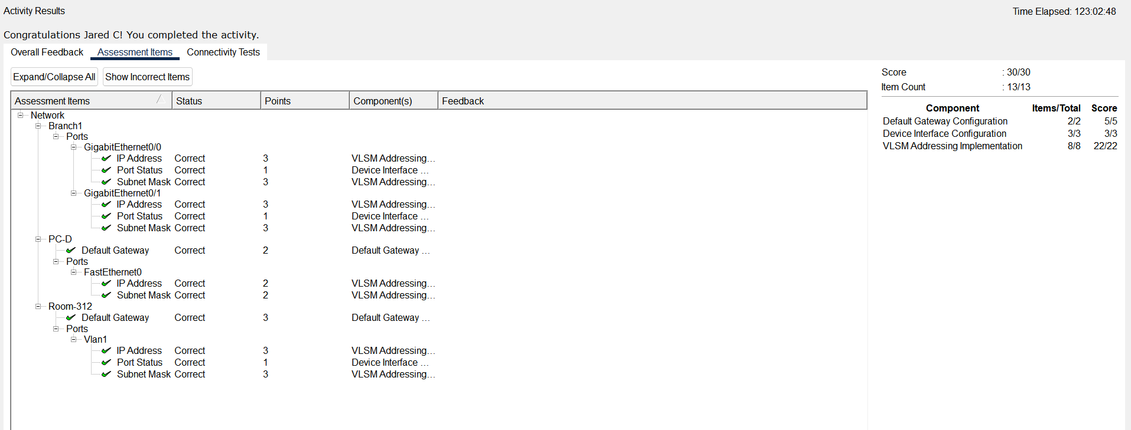of document

